Introduction of the Tick-borne diseases in the US (Literature review)
Objective1: Conduct literature reviews with a minimum of 15 evidence-based article of the top 5 tick-borne diseases in the US.

The epidemiological profile of Tick-borne diseases
Includes the objectives:
- By 9/19/19, identify the prevalence of a minimum 4 of tick-borne diseases in the United States specifically the northern states of the US from existing data.
- By 10/20/19, arrange epidemiological profile of 5 tick-borne diseases in the north east states.
Identify which competencies you will be developing during the course of your APE
FC1 Apply epidemiological methods to the breadth of settings and situations in public health practice
FC2 Select quantitative and qualitative data collection methods appropriate for a given public health context
FC3: Analyze quantitative and qualitative data using biostatistics, informatics, computer-based programming and software, as appropriate.

For instance, CDC 2016 report and NIH survey; how they collect the data, how the analyze it, what statistical test they used and strength and limitation also the result.

EPIC2: Describe a public health problem in terms of magnitude, person, time and place.
EPIC3: Apply the basic terminology and definitions of epidemiology
EPIC4: Draw appropriate inferences from epidemiologic data

After mentioning all the diseases one more category should be added that discuss the coinfection and the risk factors of the 4 diseases collectively

The epidemiological profile of Lyme disease:
Lyme disease considers one of the most tick-borne diseases in the United States (Stanek, Wormser, Gray & Strle, 2012). Lyme disease is a vector-borne disease caused the bacteria by Borrelia burgdorferi and transmitted to humans by infected blacklegged ticks or Ixodes scapularis bite mostly in immature tick stage; correspondingly, erythema migrans is one of the signs that manifests on the infected person skin (Stanek, Wormser, Gray & Strle, 2012).

- Pathogenesis and diagnosis:
The Lyme disease profile contains the disease causative agents: Borrelia burgdorferi and B. mayonii; as well as the mode of transmission: blacklegged Ixodes scapularis or Ixodes pacifica tick bite; also, the disease has two stages localized stage and disseminated stage; additionally, the incubation period: 3 days to a month (CDC, 2018). The immune response to any infection varies in every human depending on many factors (Brodin & Davis, 2016). After the infected tick feed on human blood and transfer the pathogen B. burgdorferi, the pathogen multiplies in the human’s body and develops an immune reaction (Stanek, Wormser, Gray & Strle, 2012). In the localized stage erythema migrans; while, the late stage is more serious, and it extends to arthritis, brain damage, and acrodermatitis chronica atrophicans (Steere et al., 2016). There are three different methods to detect Lyme disease in the lab such as serological test, blood test, and CPR (Stanek, Wormser, Gray & Strle, 2012). (CDC, 2018) The general blood test findings includes increase red blood cells sedimentation rate, rise in the liver enzymes, and in Lyme meningitis, CSF indicates lymphocytic pleocytosis, slightly increased protein, and normal glucose; moreover, serological tests are also required in the late stage by using the two-tier testing.
- Incidence & Prevalence:
Lyme disease has 82% reportable cases compare to the other vector-borne diseases in the North America over the period 2004-2016 (Rosenberg et al., 2018). In a retrospective analysis conducted by (Nelson et al., 2015) projected the incidence rate of Lyme disease in the United States in approximately 106/100,000 patients ≈ 329,000 cases with 95% confidence interval (296,000–376,000) every year. In a study directed in New York in a military site ‘West Point’ (Schubert & Melanson, 2019), researchers estimated around 166 cases between the period of 2016-2018 and most of the cases have been diagnosed in the summer season; moreover, 63 of the cases have been analyzed and measured to calculate the period prevalence and the result presented as 21,595 person-years with a period prevalence of 292 cases per 100,000 (219.8, 363.7).

- Geographical distribution:

The vector: The transmitted vector of Lyme disease is Ixodes scapularis, is mostly found in the northern states and the upper Midwest of the US, whereas, Ixodes pacificus is located in the western states of the US (Stanek, Wormser, Gray & Strle, 2012). The vector Ixodes scapularis lifecycle contains from 4 life stages nymph, larvae, adult female, an adult male, furthermore, the nymph peaks at the beginning summer to the beginning of the fall; while the adult becomes active at the fall to the winter and lost its activity the at the start of the spring(Stanek, Wormser, Gray & Strle, 2012).
The bacteria: The main pathogen of human Lyme disease in the United States is B. burgdorferi (Steere et al., 2016) also researchers detected a new genospecies candidatus Borrelia mayonii in the upper western of the USA (Pritt et al., 2016). Ticks carry B. burgdorferi in the midgut part of the tick’s body (Stanek, Wormser, Gray & Strle, 2012).
The host (humans): The US Department of Health and Human Services has released in ‘Tick-borne Disease Working Group 2018 report’ (HHS,2018) to the Secretary and the Congress that Lyme disease has raised by 300% in the northeastern states and 250% in the north-central states. In 2015, CDC reported that 95% of the Lyme disease patients were detected in Connecticut, Delaware, Maine, Maryland, Massachusetts, Minnesota, New Hampshire, New Jersey, New York, Pennsylvania, Rhode Island, Vermont, Virginia, and Wisconsin (CDC, 2018).

Geographical distribution of the diseases in the map:

Figure 1:

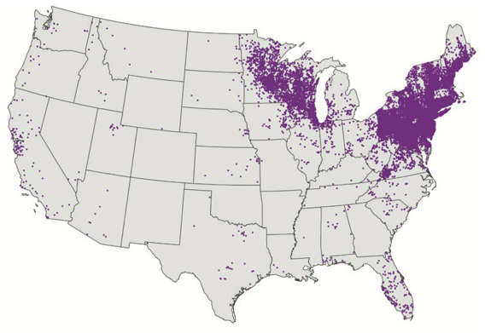

Lyme disease
Source: (Centers of Disease Control and prevention, 2018)

Geographical distribution of the vector:
Figure 2:

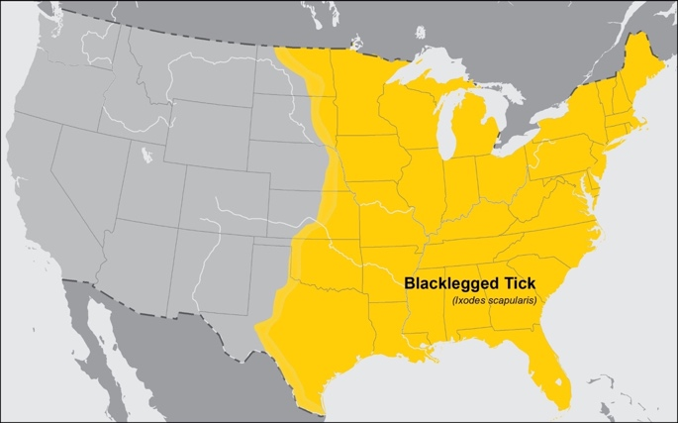
Source: (CDC,2018) “This map shows the estimated distribution of Ixodes scapularis tick populations, commonly known as blacklegged or deer ticks. However, tick abundance within this area varies locally. The map does not represent the risk of contracting any specific tickborne illness. Please consult your local health department or Cooperative Extension office to learn about the risks of tickborne disease in your local area. 08/2018”
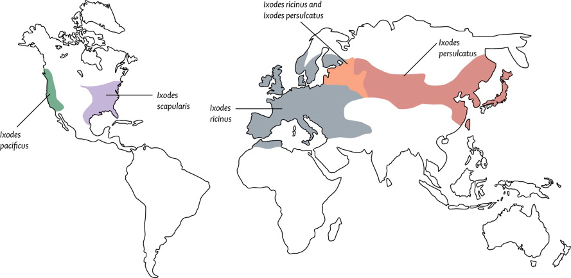
Source: Stanek, G., Wormser, G., Gray, J., & Strle, F. (2012). Lyme borreliosis. The Lancet, 379(9814), 461-473. doi: 10.1016/s0140-6736(11)60103-7

Figure 3:
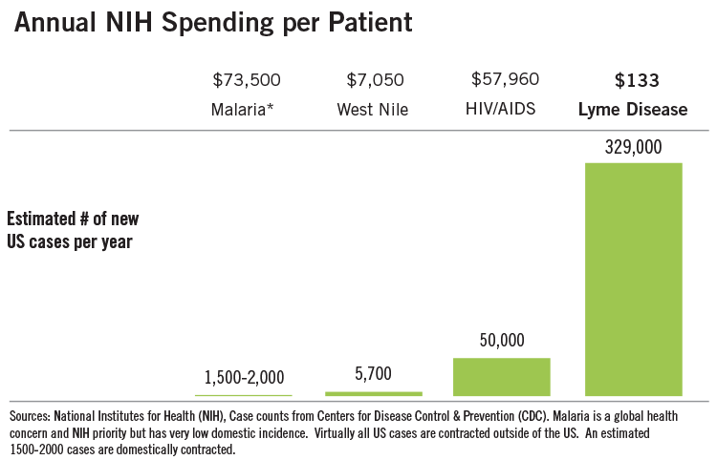
Source: Lyme Disease Co-Infection | NIH: National Institute of Allergy and Infectious Diseases. (2019). Retrieved 9 September 2019, from https://www.niaid.nih.gov/diseases-conditions/lyme-disease-co-infection
Figure 4:
Annual Number of Lyme Disease Cases
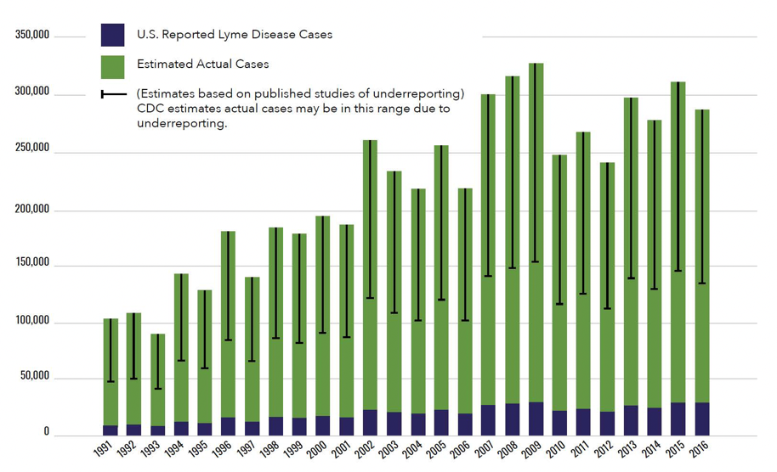
Source: The U.S. Department of Health and Human Services Tick-borne disease working group 2018 report to congress. Retrieved from https://www.hhs.gov/sites/default/files/tbdwg-report-to-congress-2018.pdf

Ref:

Nelson CA, Saha S, Kugeler KJ, Delorey MJ, Shankar MB, Hinckley AF, et al. Incidence of Clinician-Diagnosed Lyme Disease, United States, 2005-2010. Emerg Infect Dis. 2015;21(9):1625–31.
Rosenberg, R., Lindsey, N., Fischer, M., Gregory, C., Hinckley, A., & Mead, P. et al. (2018). Vital Signs: Trends in Reported Vectorborne Disease Cases — United States and Territories, 2004–2016. MMWR. Morbidity And Mortality Weekly Report, 67(17), 496-501. doi: 10.15585/mmwr.mm6717e1
The U.S. Department of Health and Human Services Tick-borne disease working group 2018 report to congress. Retrieved from https://www.hhs.gov/sites/default/files/tbdwg-report-to-congress-2018.pdf
Stanek, G., Wormser, G., Gray, J., & Strle, F. (2012). Lyme borreliosis. The Lancet, 379(9814), 461-473. doi: 10.1016/s0140-6736(11)60103-7
Schubert, S., & Melanson, V. (2019). Prevalence of Lyme Disease Attributable to Military Service at the USMA, West Point NY: FY2016–2018. Military Medicine. doi: 10.1093/milmed/usz156
Centers for Disease Control and Prevention. Tick-borne disease of the United States a reference manual for healthcare providers Fifth Edition, 2018. Retrieved from https://www.cdc.gov/ticks/tickbornediseases/TickborneDiseases-P.pdf
Lyme Disease Co-Infection | NIH: National Institute of Allergy and Infectious Diseases. (2019). Retrieved 9 September 2019, from https://www.niaid.nih.gov/diseases-conditions/lyme-disease-co-infection *Figure 3*
Steere, A., Strle, F., Wormser, G., Hu, L., Branda, J., & Hovius, J. et al. (2016). Lyme borreliosis. Nature Reviews Disease Primers, 2(1). doi: 10.1038/nrdp.2016.91

Pritt, B., Mead, P., Johnson, D., Neitzel, D., Respicio-Kingry, L., & Davis, J. et al. (2016). Identification of a novel pathogenic Borrelia species causing Lyme borreliosis with unusually high spirochaetaemia: a descriptive study. The Lancet Infectious Diseases, 16(5), 556-564. doi: 10.1016/s1473-3099(15)00464-8

Brodin, P., & Davis, M. (2016). Human immune system variation. Nature Reviews Immunology, 17(1), 21-29. doi: 10.1038/nri.2016.125

- The epidemiological profile of Babesiosis:

Babesiosis is a protozoan infection that infected the red blood cells via Babesia microti and transmitted by the same tick as the Lyme disease an infected Ixodes scapularis also, babesiosis unlike Lyme disease in terms of the geographical distribution, it considers rare disease even though it shares the same vector as Lyme disease (Diuk-Wasser et al., 2014). According to the CDC, Ixodes scapularis, in other word, blacklegged tick lives in grassy, wooded and brushy area; moreover, people expose to the tick or the nymph while involving in outdoor activities and most of the time people find it difficult to observe or feel the tick bite ("CDC - Babesiosis - Epidemiology & Risk Factors", 2019).

- Incidence & Prevalence:

- Clinical information:
The second TB disease is babesiosis including the agents: Babesia microti and other Babesia species; also, the disease could be transmitted by the vector Ixodes scapularis ticks and the signs of the disease are mostly asymptomatic, however, sometimes it could be lethal; lastly, the incubation period is one to more than nine weeks (CDC, 2018).
- Geographical distribution:
The CDC demonstrated in the 2016 report that cases have been found of Babesiosis in the east coast states, west coast states, southern states, northern states; additionally, anaplasmosis cases have been found in Colorado, Idaho, New Mexico, Alaska, and Hawaii in (2016, CDC).

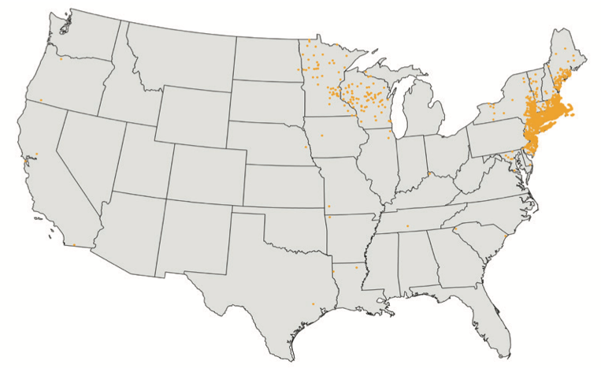
Babesiosis
(Centers of Disease Control and prevention, 2018)

Risk factors:
Blood transfusion

Reference:

Diuk-Wasser, M., Liu, Y., Steeves, T., Folsom-O’Keefe, C., Dardick, K., & Lepore, T. et al. (2014). Monitoring Human Babesiosis Emergence through Vector Surveillance New England, USA. Emerging Infectious Diseases, 20(2), 225-231. doi: 10.3201/eid1302/130644
Centers for Disease Control and Prevention- Babesiosis - Epidemiology & Risk Factors. (2019). Retrieved 9 September 2019, from https://www.cdc.gov/parasites/babesiosis/epi.html
Centers for Disease Control and Prevention. Tick-borne disease of the United States a reference manual for healthcare providers Fifth Edition, 2018. Retrieved from https://www.cdc.gov/ticks/tickbornediseases/TickborneDiseases-P.pdf

- The epidemiological profile of Anaplasmosis:
Granulocytic anaplasmosis is an acute infection that caused by transmission of two species of infected tick (Ixodes scapularis and Ixodes pacificus) with A.phagocytophilum bacterium to produce flu-like symptoms (Dahlgren, Heitman, Behravesh, Drexler & Massung, 2015).

- Incidence & Prevalence:
In a study estimated the incidence rate of anaplasmosis between 2008-2012 that 6.3 cases per million persons annually and most of the cases reported in the northeastern and upper Midwestern states (Biggs et al., 2016).

- Clinical information:
The agent of anaplasmosis is the bacterium A. phagocytophilum and may associated with contaminated blood transfusion; and the vector of the disease is the same tick that cause Lyme disease and babesiosis I. scapularis (2016, CDC). The incubation period is between about one to two weeks and the patients develop flu-like symptoms with gastrointestinal discomfort; furthermore, the laboratory results include mild anemia, thrombocytopenia, leukopenia and increase in hepatic transaminases (2016, CDC).

- Geographical distribution:
The majority of anaplasmosis cases reported during the period June-Nov and mostly located in the northeastern and upper Midwestern states especially in Wisconsin and Minnesota, especially in Wisconsin and Minnesota (Biggs et al., 2016).

- Risk factors:
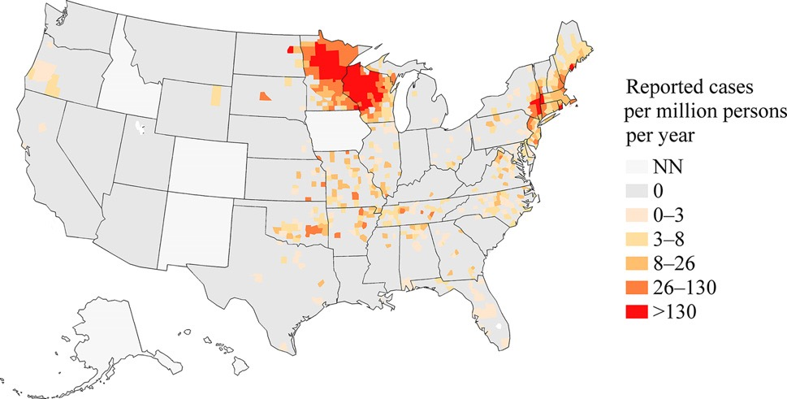
Source: “A map of reported incidence rates, the number of incident cases per million persons at risk per year, of anaplasmosis in the counties of the United States, 2008–2012. States where the disease was not notifiable for the duration of 2008–2012 are shaded with the “NN” category. The number of incident cases is from the Nationally Notifiable Diseases Surveillance System, and the number of person-years at risk is from the U.S. Census Bureau” (Dahlgren, Heitman, Behravesh, Drexler & Massung, 2015).

Reference:

Dahlgren, F., Heitman, K., Behravesh, C., Drexler, N., & Massung, R. (2015). Human Granulocytic Anaplasmosis in the United States from 2008 to 2012: A Summary of National Surveillance Data. The American Journal of Tropical Medicine and Hygiene, 93(1), 66-72. doi: 10.4269/ajtmh.15-0122
Biggs, H., Behravesh, C., Bradley, K., Dahlgren, F., Drexler, N., & Dumler, J. et al. (2016). Diagnosis and Management of Tickborne Rickettsial Diseases: Rocky Mountain Spotted Fever and Other Spotted Fever Group Rickettsioses, Ehrlichioses, and Anaplasmosis — United States. MMWR. Recommendations and Reports, 65(2), 1-44. doi: 10.15585/mmwr.rr6502a1
Centers for Disease Control and Prevention. Tick-borne disease of the United States a reference manual for healthcare providers Fifth Edition, 2018. Retrieved from https://www.cdc.gov/ticks/tickbornediseases/TickborneDiseases-P.pdf

- The epidemiological profile of Rocky-mountain Spotted Fever:

Rocky Mountain Spotted Fever is a serious vector-borne disease and bacterial infection caused by Rickettsia and transmitted by an infected tick bite; two of tick species have found to cause RMSF, Dermacentor variabili known as the American dog tick and most of the cases reported in the eastern and central states of the United States; whereas, the other species D. andersoni known as the Rocky Mountain Wood tick has found in west coast of the USA (Demma et al., 2005).
Incidence & Prevalence:
According to study conducted by (Biggs et al., 2016) stated that regarding the passive surveillance that has done during 2008-2012 estimated the incidence rate of RMSF 8.9 cases per million person and the age group 60-69 having the highest incidence rate.

Clinical information:
RMSF is fatal and rare vector-borne disease that transmitted by an infected tick that has Rickettsia bacterium; physicians find challenges to diagnose the disease according to the study conducted by (McClain & Sexton, 2019). The symptoms start with flu-like symptoms and end with spotted rash and central nervous system and renal damage; incubation period 3-12 days and it considers a rapidly lethal if it was not treated; moreover, the laboratory findings include thrombocytopenia, elevated hepatic transaminases, and Hyponatremia (2018, CDC).
Geographical distribution:
According to the annual report of the CDC 2016 mentioned that 63% of the cases were reported in the states Arkansas, Missouri, North Carolina, Oklahoma, and Tennessee

Risk factors:
Outdoor activities
Ocupation
Coinfection

Reference:

Demma, L., Traeger, M., Nicholson, W., Paddock, C., Blau, D., & Eremeeva, M. et al. (2005). Rocky Mountain Spotted Fever from an Unexpected Tick Vector in Arizona. New England Journal of Medicine, 353(6), 587-594. doi: 10.1056/nejmoa050043
McClain, M., & Sexton, D. (2019). Surveillance for Spotted Fever Group Rickettsial Infections: Problems, Pitfalls, and Potential Solutions. The Journal of Infectious Diseases. doi: 10.1093/infdis/jiz317
Centers for Disease Control and Prevention. Tick-borne disease of the United States a reference manual for healthcare providers Fifth Edition, 2018. Retrieved from https://www.cdc.gov/ticks/tickbornediseases/TickborneDiseases-P.pdf

